MOCKUP PORTFOLIO

Nama : Bayu Krisna

NIM : 2010651095

Tampilan Home

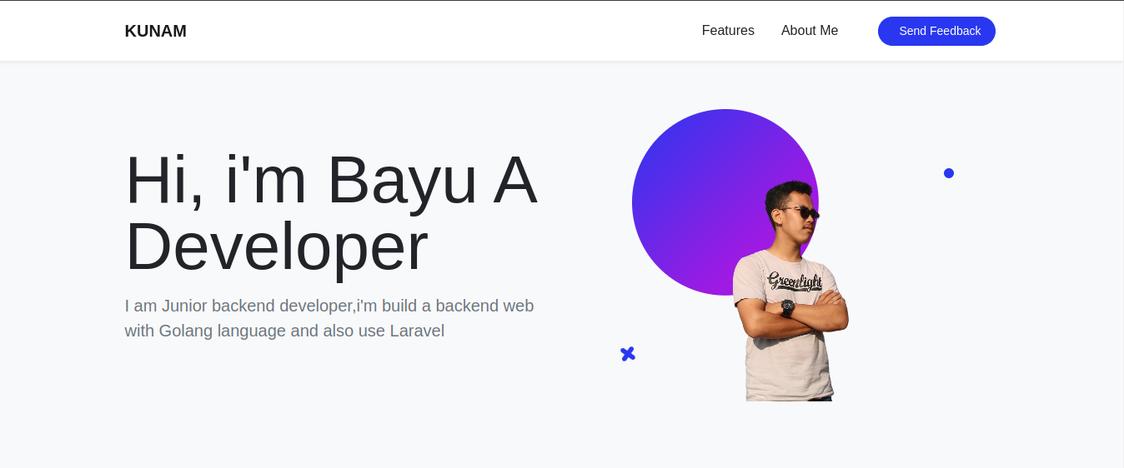

Tampilan About Me



Tampilan Features

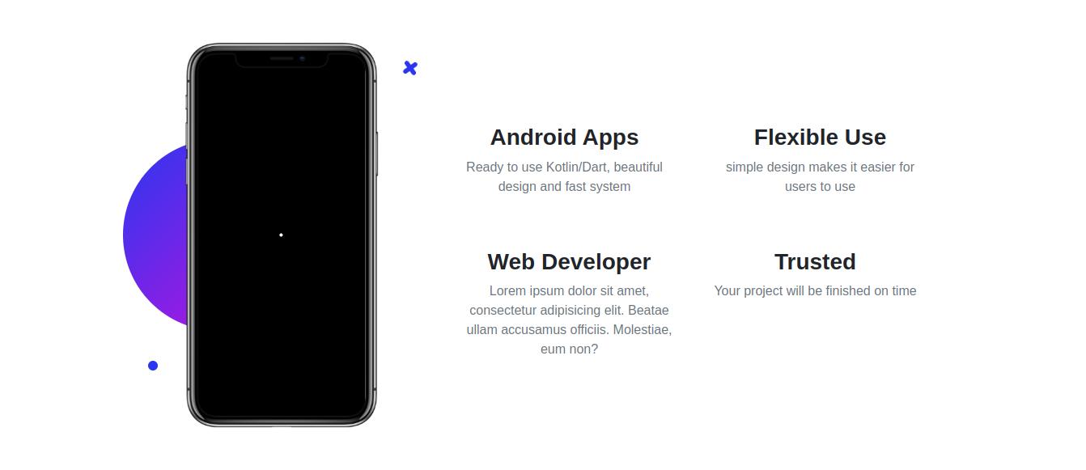

Tampilan Projects



Tampilan Send Feedback

